Screenshots of coding tasks 1 and 2 output:
Coding task 1:
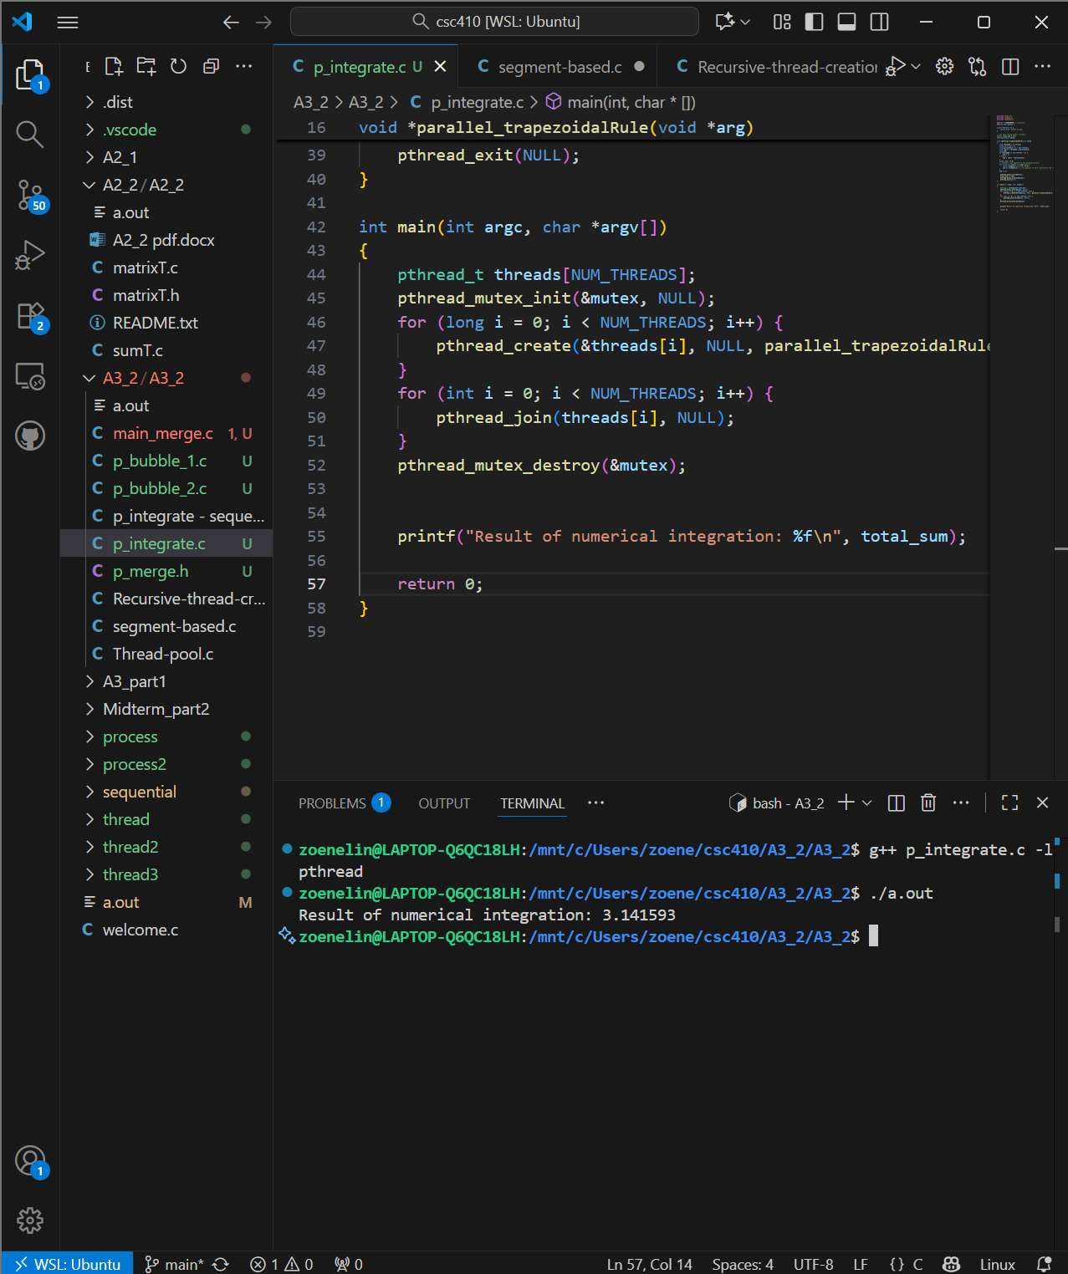
Coding task 2 – approach 1:
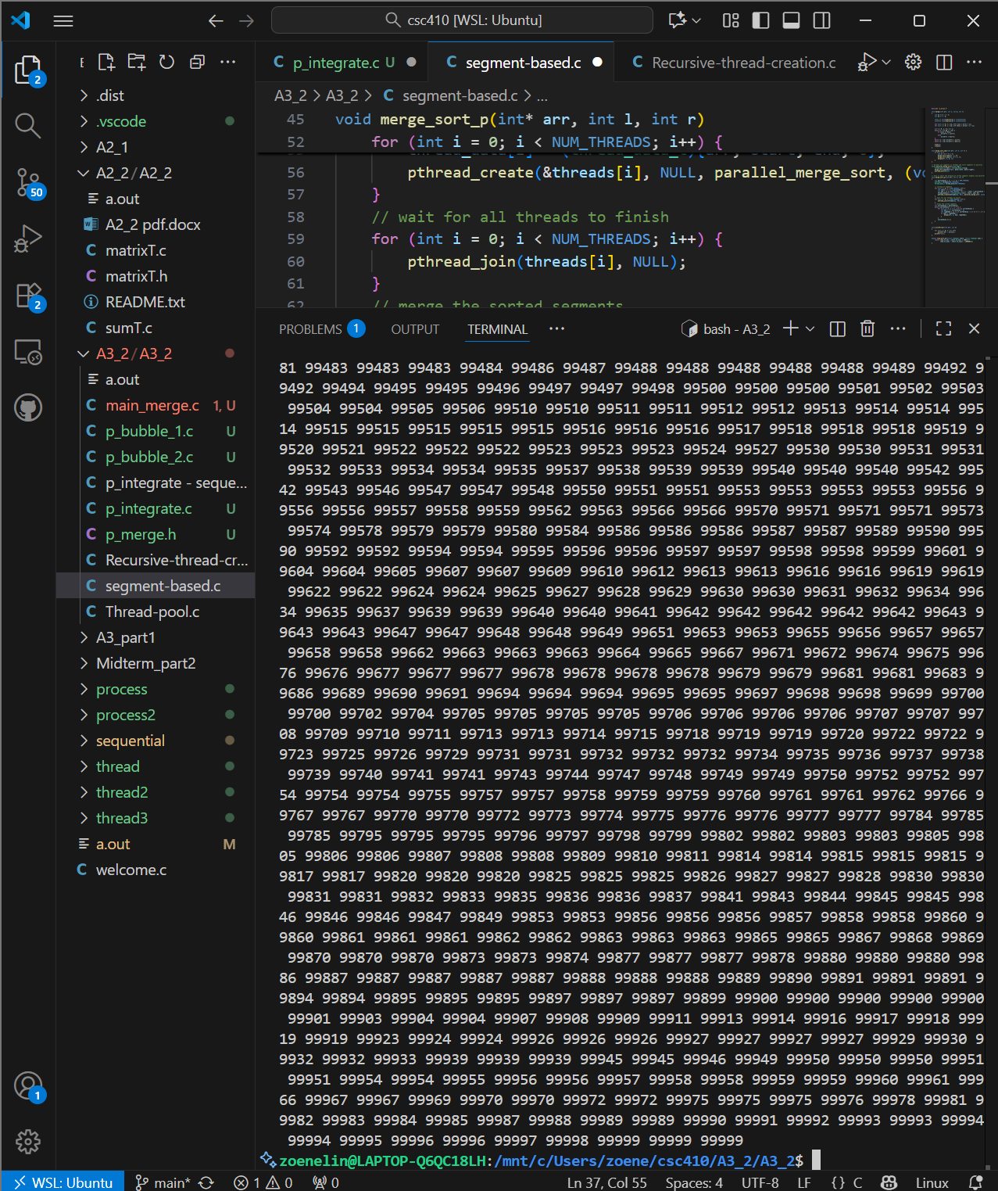
Coding task 2 – approach 2:
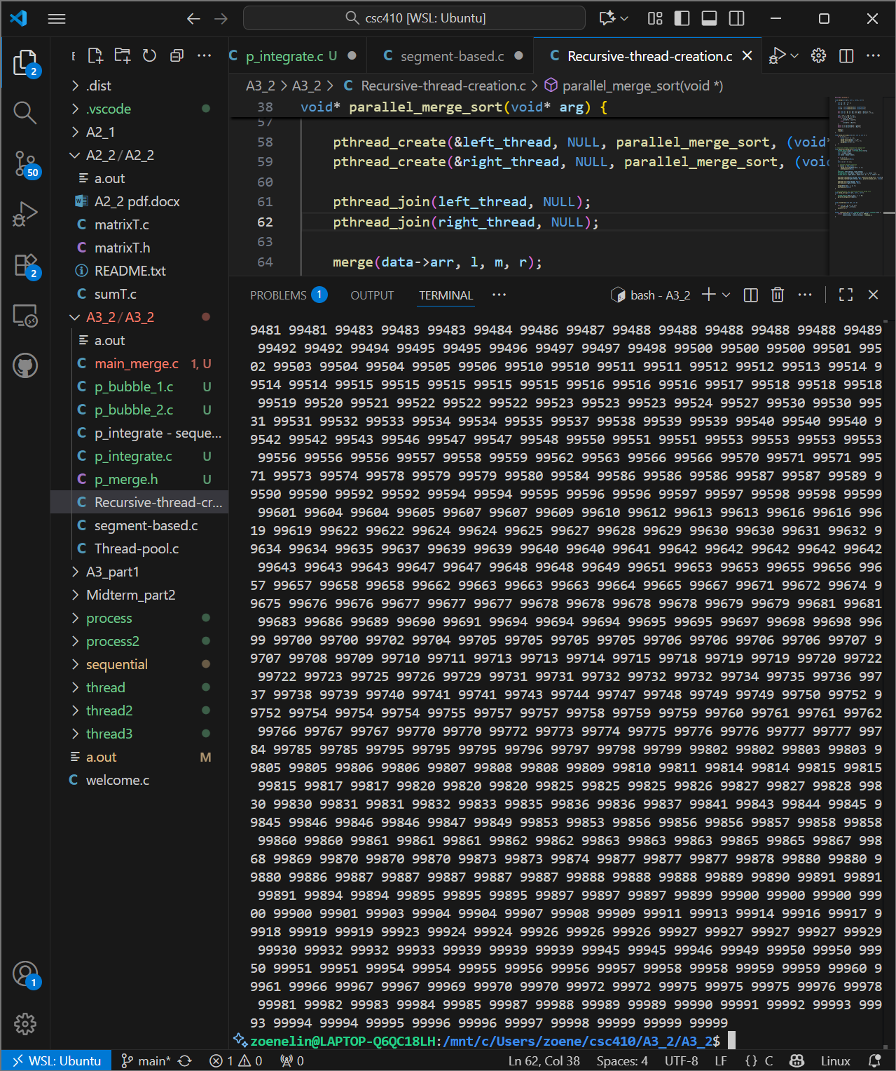
Coding task 2 – approach 3:
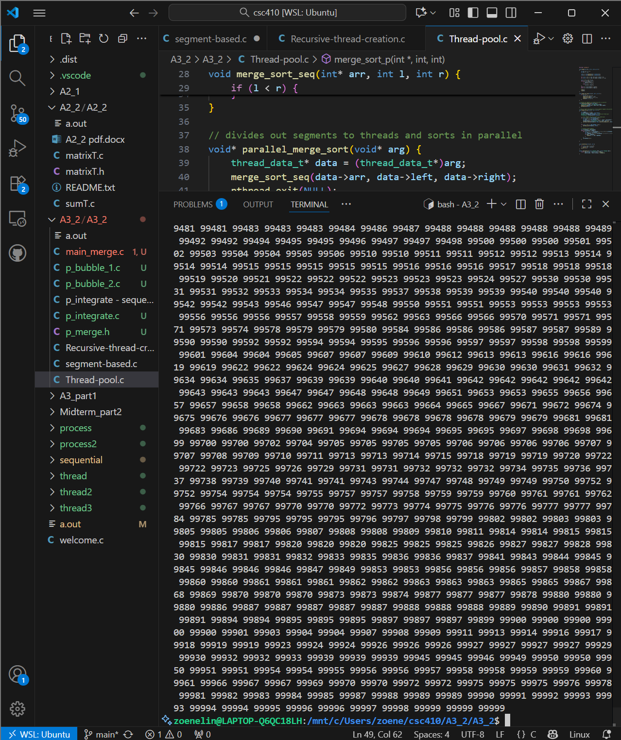

Task 3:
p_bubble_1.c
Each thread gets a segment of the array and performs the bubble sort on its segment. All the threads, after each pass uses barrier to avoid racing conditions and to swap array elements if needed between thread segments. Barrier wait makes sure all threads finish before continuing to the next pass.
The advantages of this approach is the safety between passes, scalability – due to each thread getting a chunk size, simple to implement.
The limitations are the waiting around threads do to barrier wait and the minimal speedup gained.

p_bubble_2.c
uses even / odd sort where during the even and odd phases different pairs of elements are compared and swapped. Barrier is used for the threads at each phase before moving onto the next phase before moving onto the next phase. The threads are comparing and swapping at different parts of the array simultaneously.
The advantages of using even / odd with barrier is better scalability and better parallelism, since threads work at different segments of the array and do the sorting for their individual segment at the same time.
The limitations of this approach include the imbalance of workload some threads may face especially with a larger number of threads.

Task 4:
Note:
- Using N = 1,000,000,000 for numerical integration and SIZE = 100,000 for the sorting algorithms.
- Using print statements to verify the output during testing, commenting them out when measuring execution time to ensure accurate performance results.
Program | Sequential | 1 Thread | 2 Threads | 3 Threads | 4 Threads
Num_Integrate | 0m0.006s | 0m2.607s | 0m1.325s | 0m0.882s | 0m0.661s
Merge_approach_1 | 0m0.053s | 0m0.053s | 0m0.038s | 0m0.047s | 0m0.043s
Merge_approach_2 |  | 0m0.049s | 0m0.050s | 0m0.46s | 0m0.48s
Merge_approach_3 |  | 0m0.056 | 0m0.043s | 0m0.040s | 0m0.041s
Bubble_1 | 0m027.775s | 0m27.775s | 0m19.704s | 0m15.659s | 0m14.250s
Bubble_2 |  | 0m5.557s | 0m5.132s | 0m5.100s | 0m5.485s

After thoughts when benchmarking the timing of the sequential and parallel versions of the programs listed above:
For task 3 I thought from looking at the source code of bubble 1 and bubble 2 I predicted/assumed that bubble 2 with even odd phases and use of barrier would perform better then bubble 1 and have better parallelism. I don’t know if using gcc vs g++ effects the timing or if I did something wrong, but the timing benchmarks shows little to no difference in time based on the amount of threads used. The results I got are inconsistent, with 3 threads being the sweet spot. Bubble 1 saw improvements with each thread added, with adding a fourth thread the increase in speed slowed down, only improving by one second. With bubble 2 I wonder now if the barrier for every phase is slowing down the parallelism or if load imbalance effects are the reason my benchmark times are inconsistent in improving times with the adding of threads.

Task 5:
[posted on D2L Discussion board -> Processes and Threads]
- Summarize your observations from tasks 1 -4 (performance differences, unexpected behavior, insights gained, …)
The p_integrate / num_integrate program had the best speedup with the addition of more threads. This program showed the greatest increase in performance with parallelism. Approach 2 / Recursive-thread-creation saw the least amount of speedup in comparison to the other two approaches. Approaches 1 & 3 saw slightly more gains (Approach 1 having the greatest speedup at 2 threads, and Approach 3 having the greatest speedup at 3 threads). Bubble 1 saw increased speedup with each added thread, and unlike I had thought, Bubble 2 (for me at least — maybe I messed something up) had little to no difference in speedup regardless of the number of threads. I’m guessing that in Bubble 2, the barrier for every phase is slowing down the parallelism, or maybe load imbalance effects are the reason my benchmark times are inconsistent when adding threads.
- What key considerations did you have to make when parallelizing different programs using pthreads
Key considerations I had to make when parallelizing different programs using pthreads were the division of workloads between the threads, the limiting of threads created in order to avoid thread explosion in the recursive-thread-creation approach to the merge sort program, and the use of barriers and thread joins with phases to avoid race conditions or deadlocks.
- What are the benefits and challenges of using pthreads
Using pthreads, you can control threads and their synchronizing (showcased in Approach 2 very well), and use primitives. The challenges faced when using pthreads include overhead and workload imbalances (I’m assuming this is showcased in Bubble 2), and knowing which cases it’s best used in to optimize already existing algorithms. Other challenges include the management of synchronization primitives, shared resources (like elements in the array), and the creation of threads throughout the process.

